Supervised Learning Using SAS

1. Using the breast-cancer-dataset.csv:

a. Read the file in SAS and display the contents using the import and print procedures.

proc import
out=breast_cancer
datafile="C:\Users\ekaterina.grigoreva\Desktop\breast_cancer_dataset.csv"
dbms=csv replace;
getnames=yes;
proc print data=breast_cancer;
title "Breast Cancer Dataset";
run;

The screenshot of the above code:

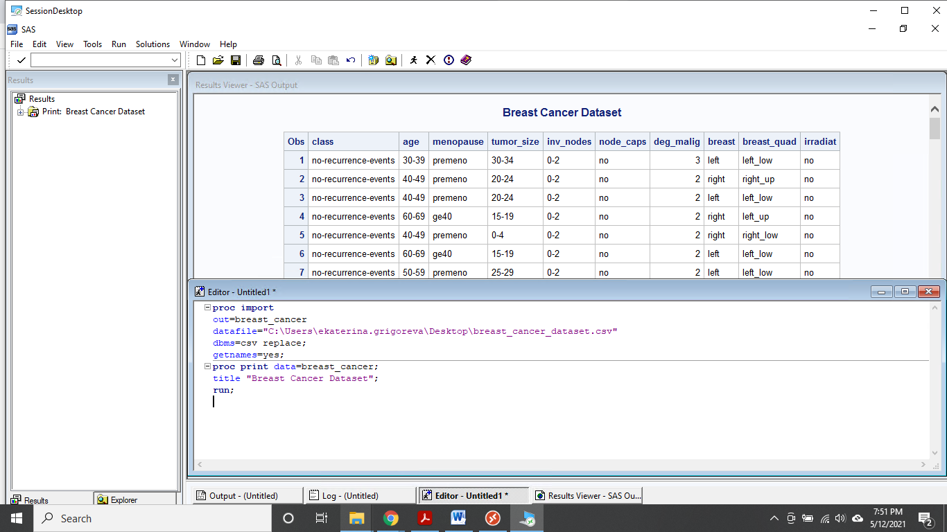

The screenshots of the dataset are below:

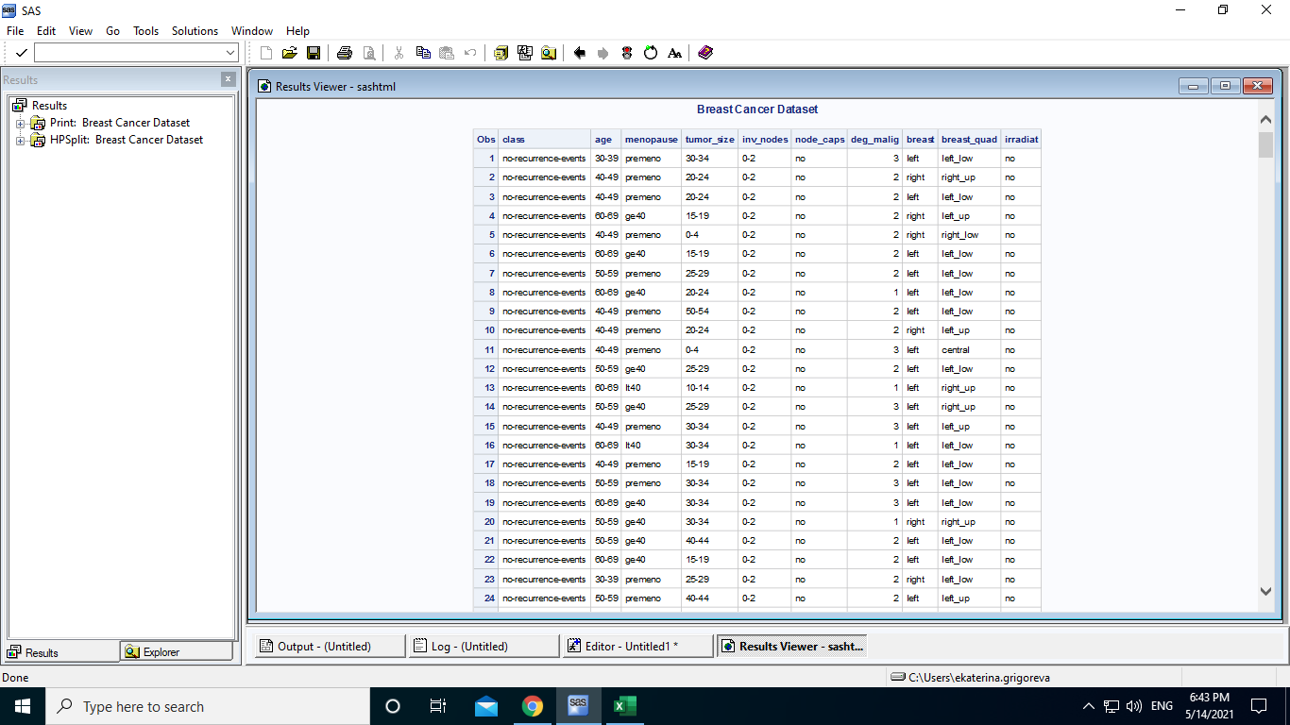
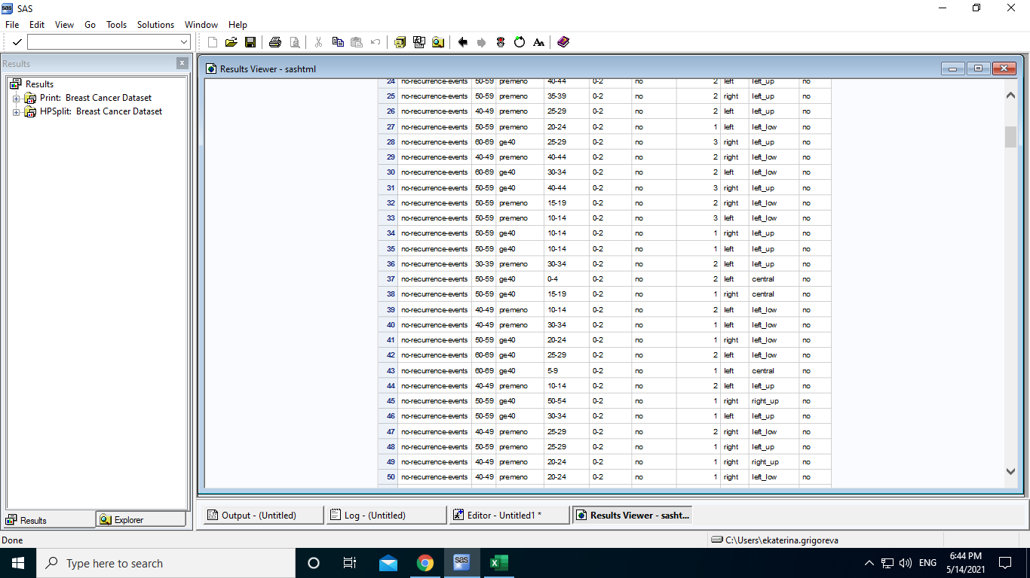
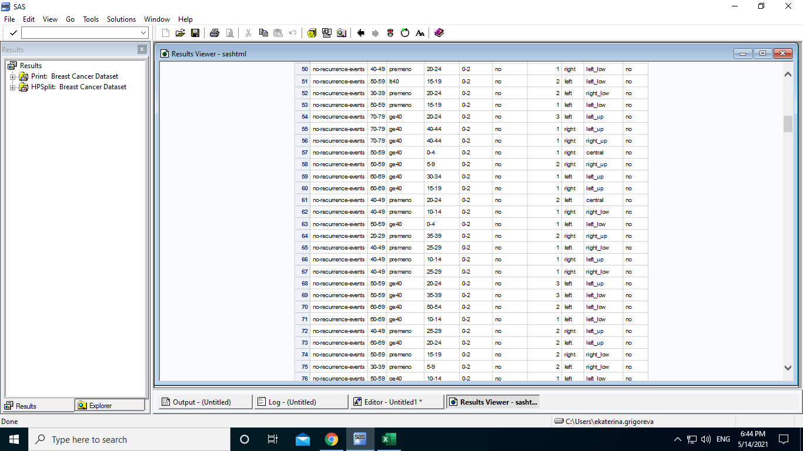
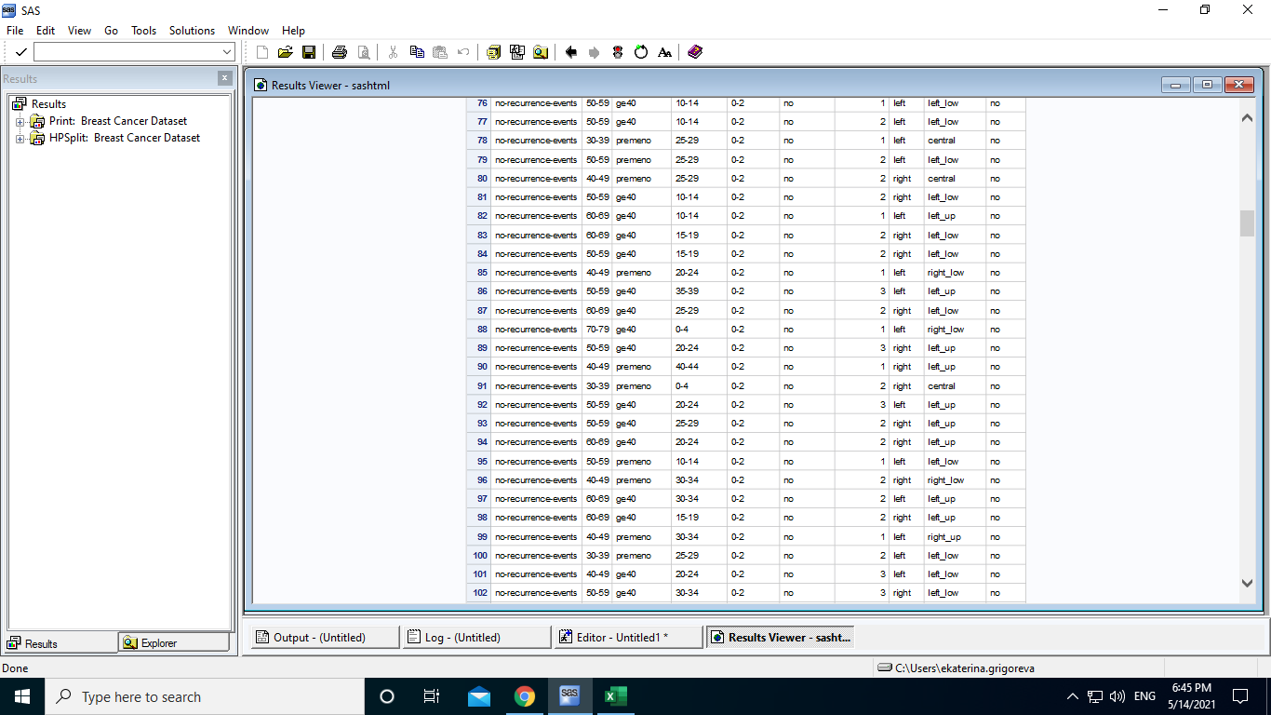
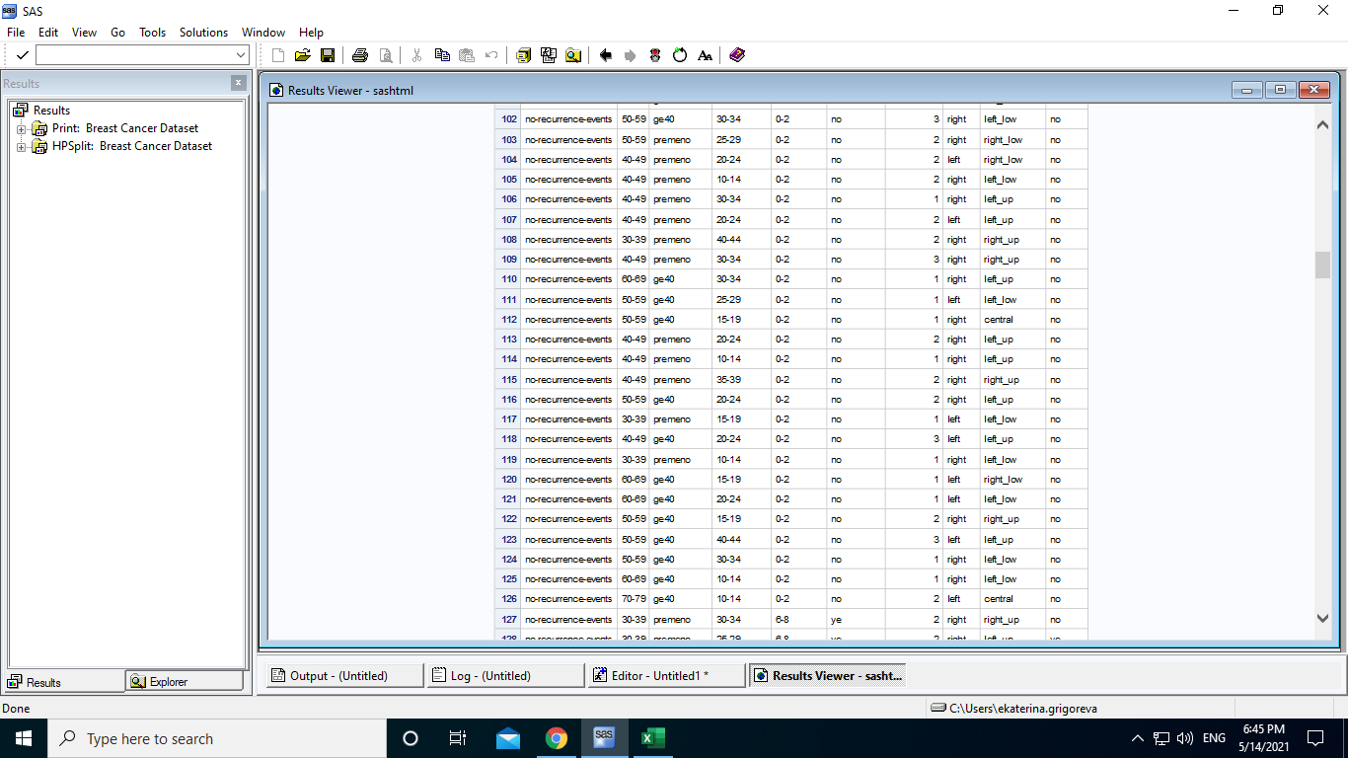
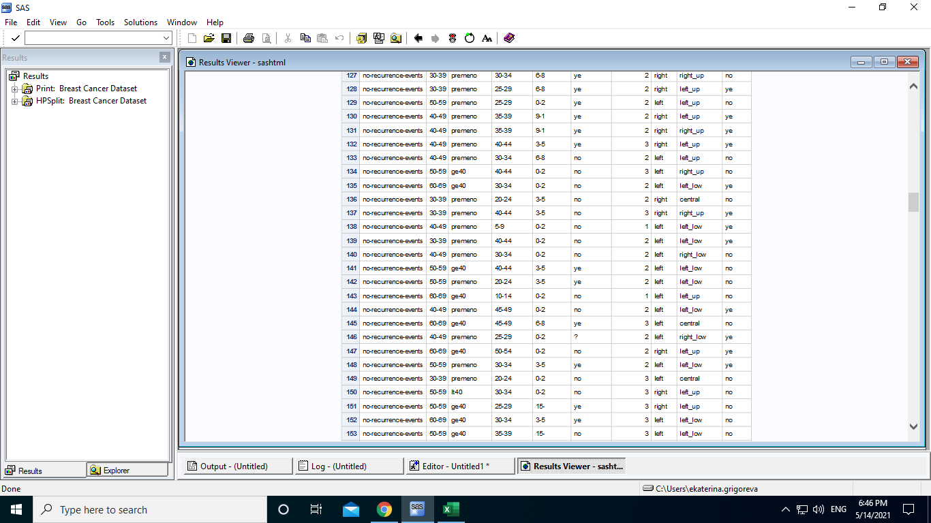
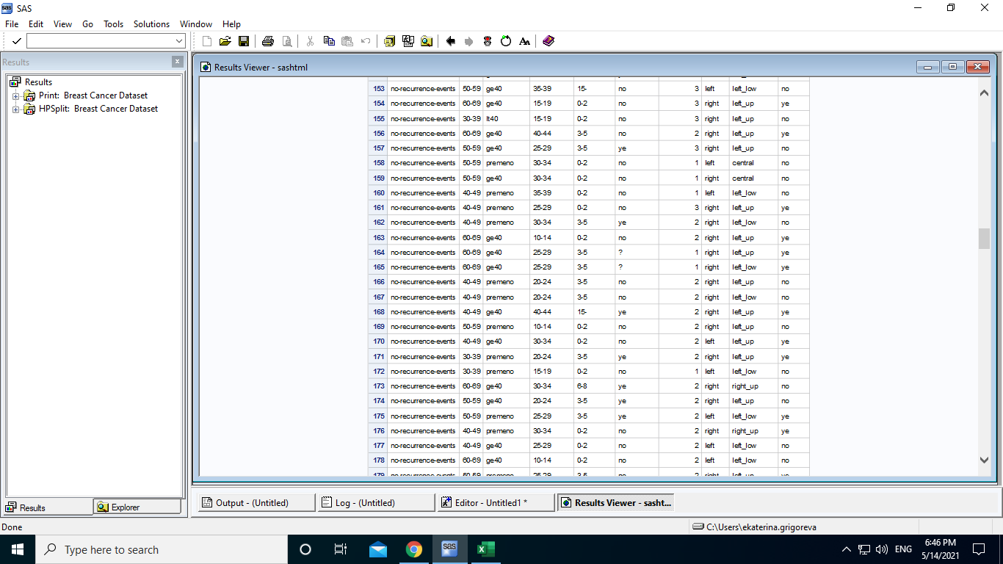
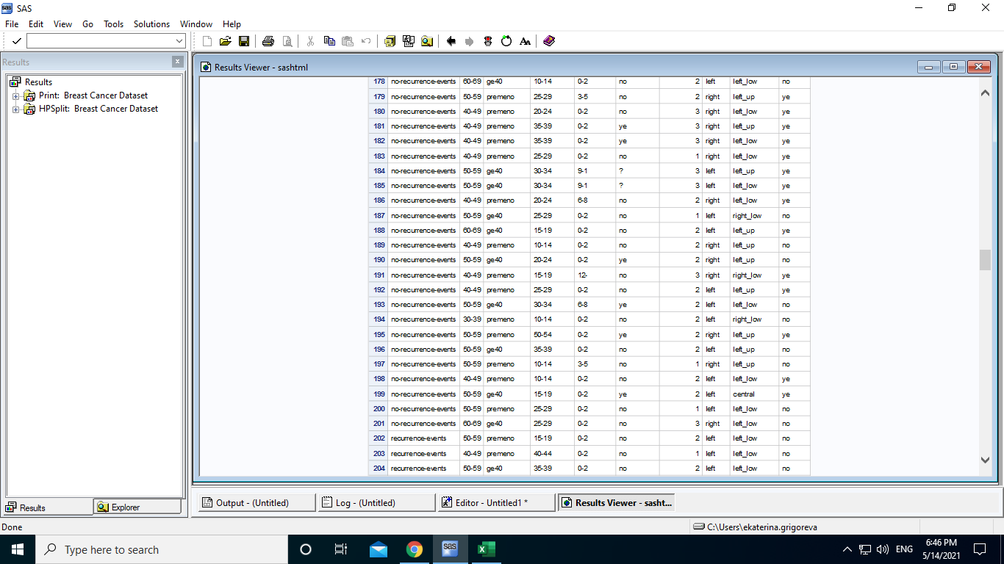
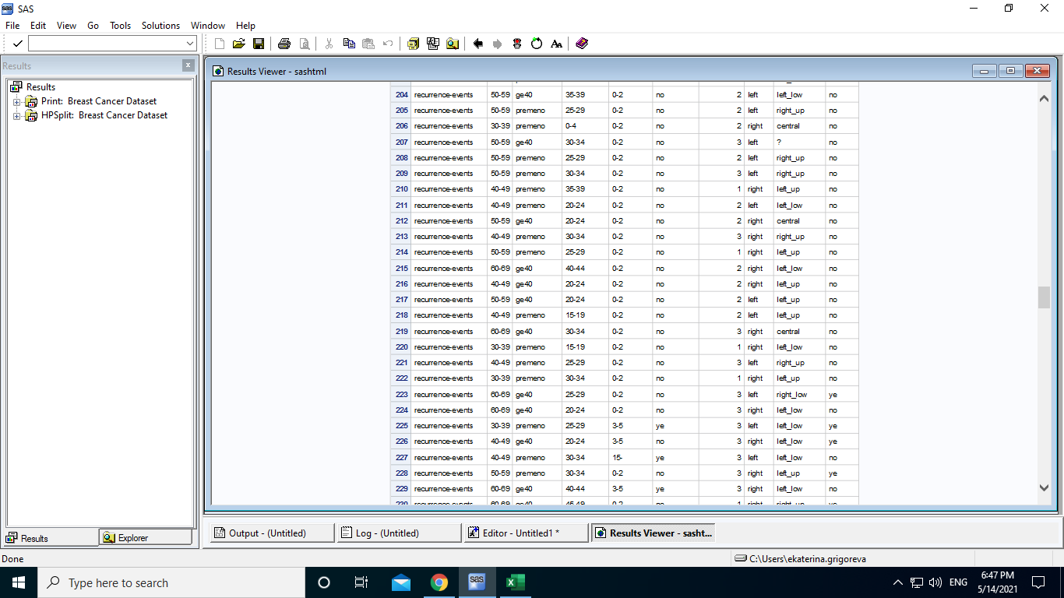
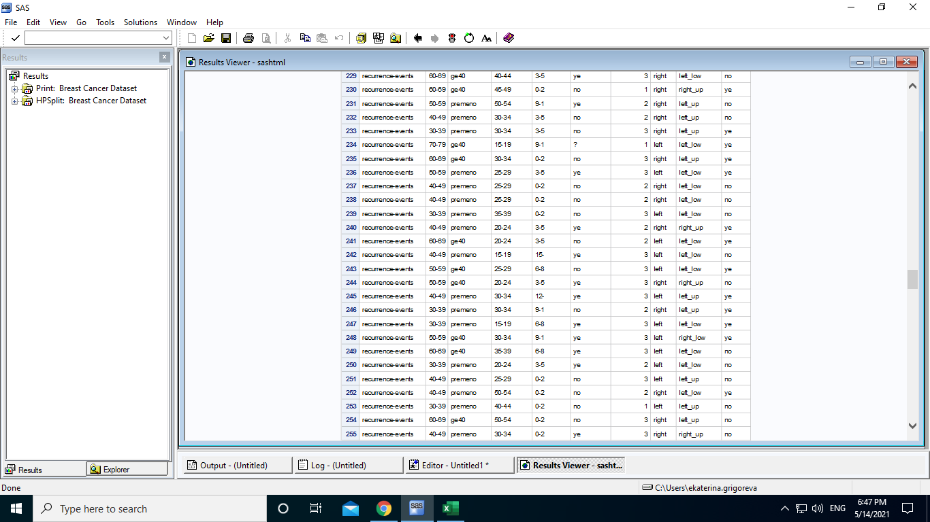
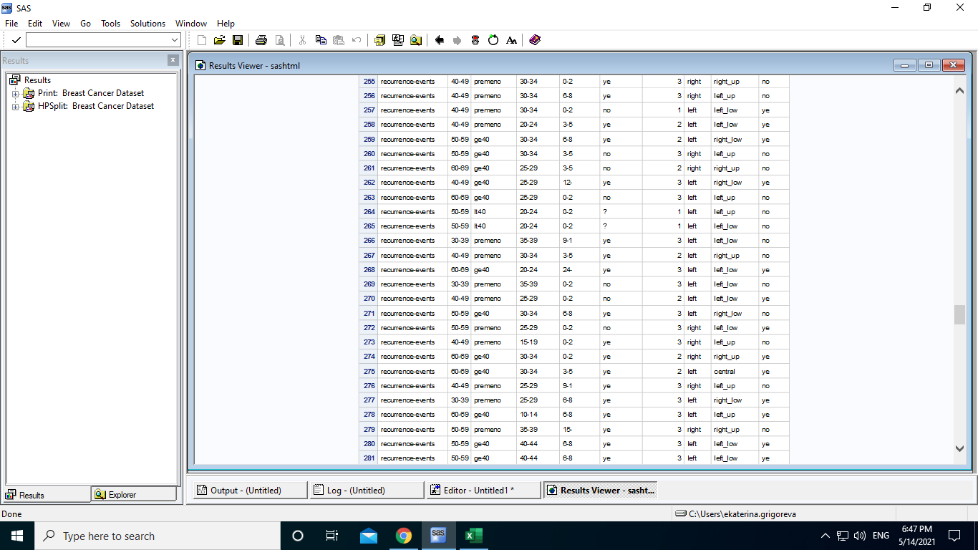
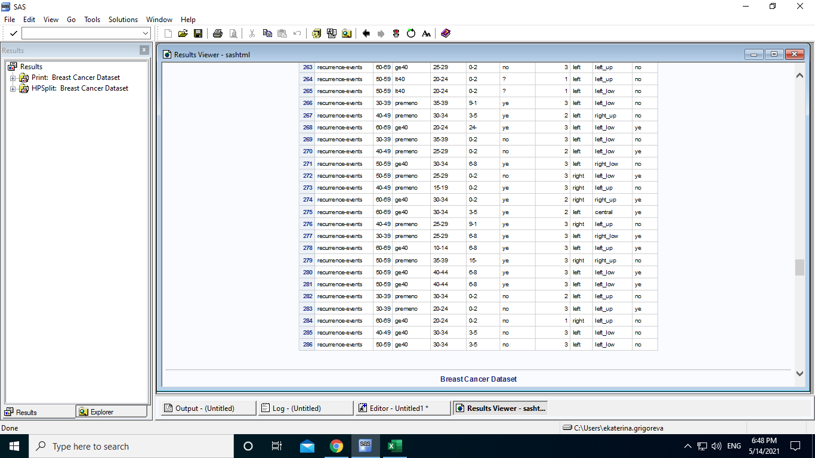

b. Develop a decision tree-based classification model using the hpsplit procedure of SAS.

ods graphics on;

proc hpsplit data=breast_cancer;
class class age menopause tumor_size inv_nodes node_caps deg_malig breast breast_quad irradiat;
model class=class age menopause tumor_size inv_nodes node_caps deg_malig breast breast_quad irradiat;
grow entropy;
prune costcomplexity;
run;

The screenshot of the above code:

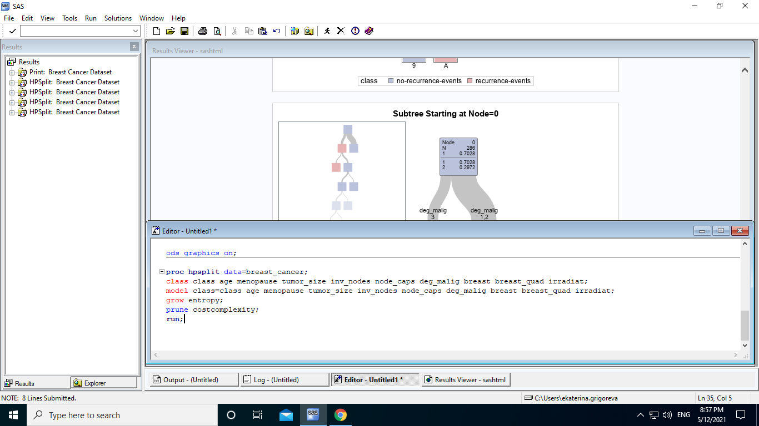

The result of the above code is shown by the following screenshots:

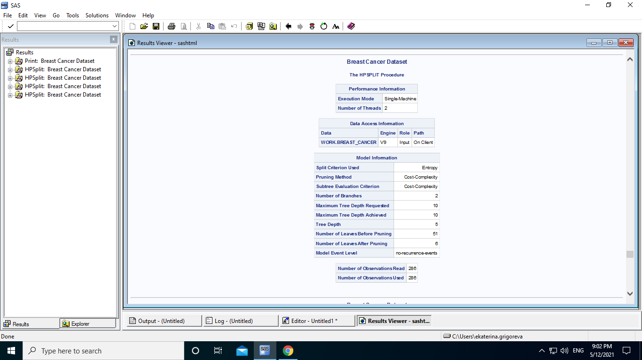

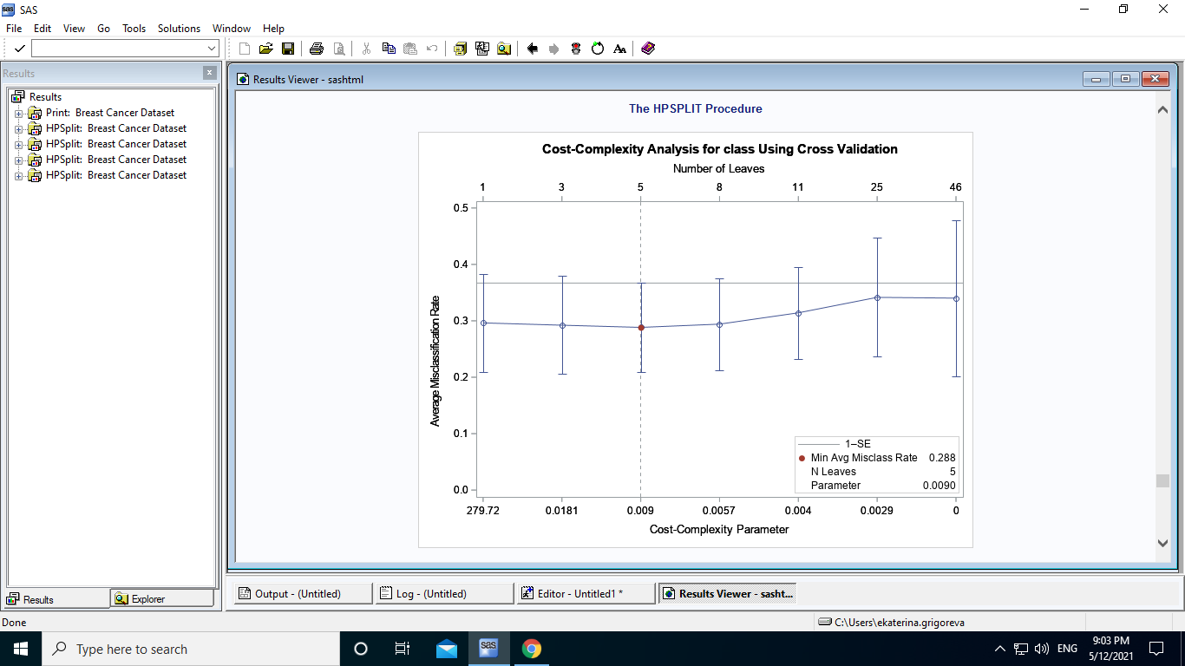

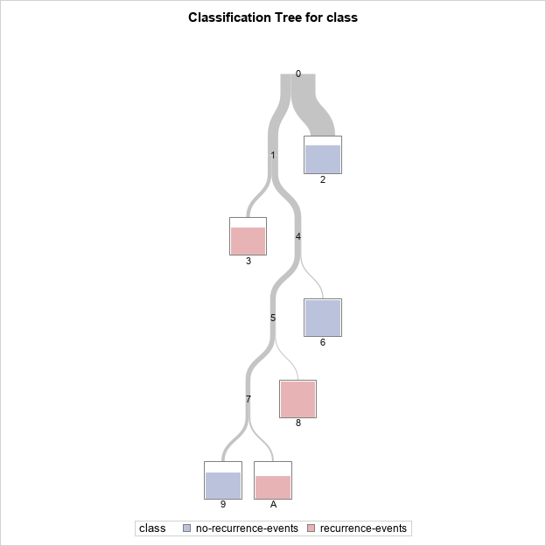

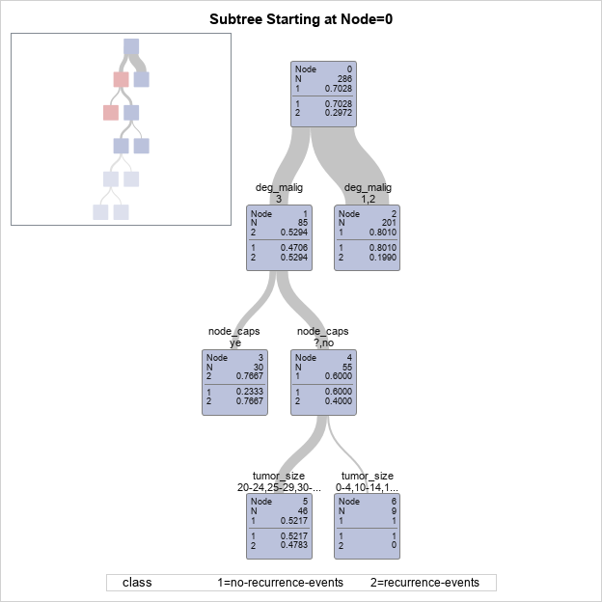

The resulting decision tree has 286 examples at the root node. Each decision node in the tree is labeled with the corresponding independent variable name and split value. The leaf nodes show the classification decision.
Based on the decision tree, deg_malig is the most important variable in splitting observations further. If deg_malig is 1 or 2, the observations go to the right (201 observations), if deg_malig is 3, the observations go to the left (85 observations). The splitting goes further until the decision tree classifies the observations in 6 leaves.

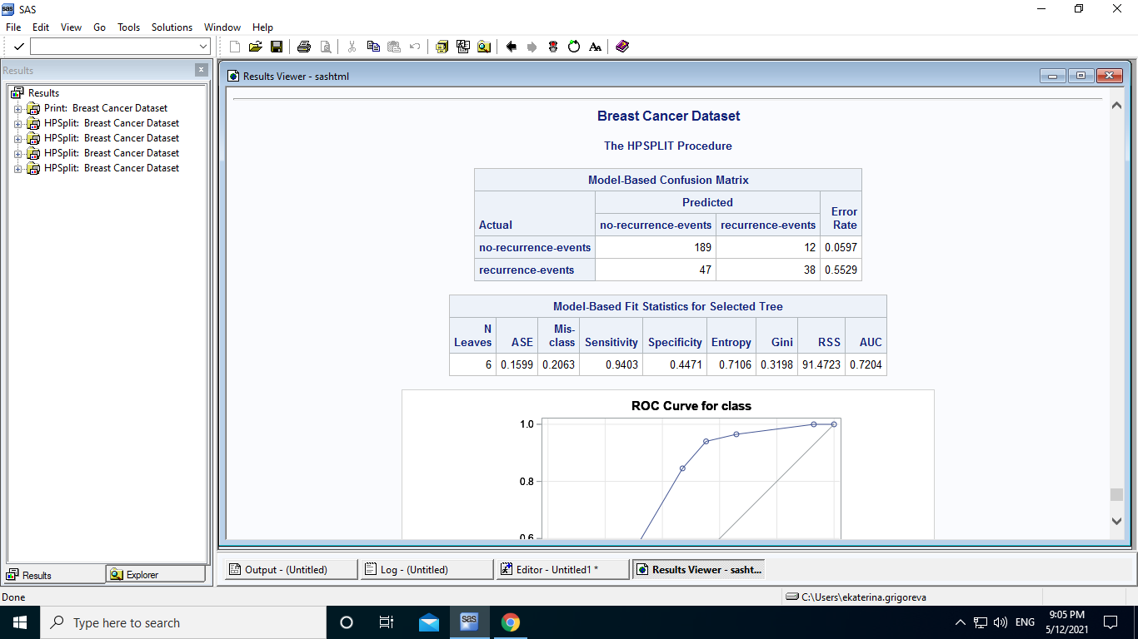

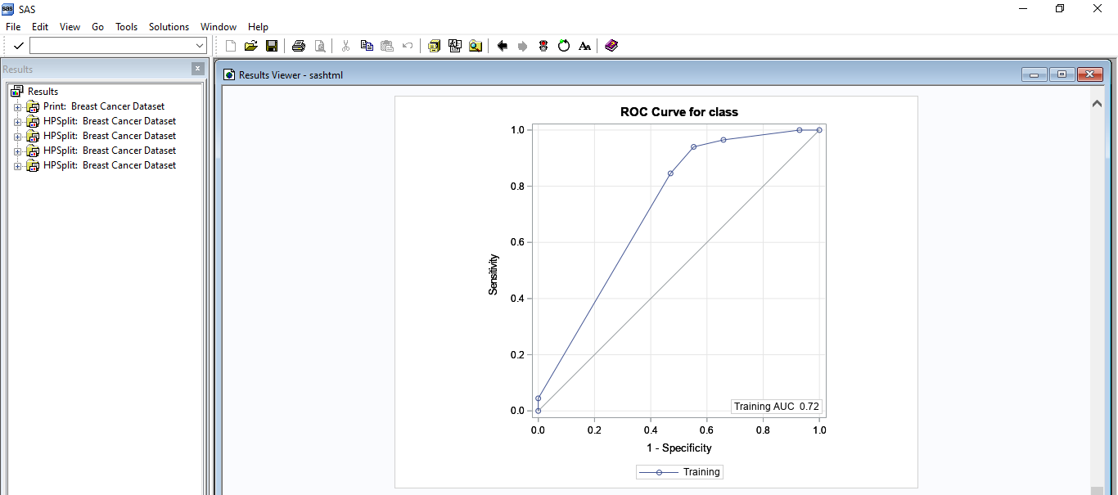

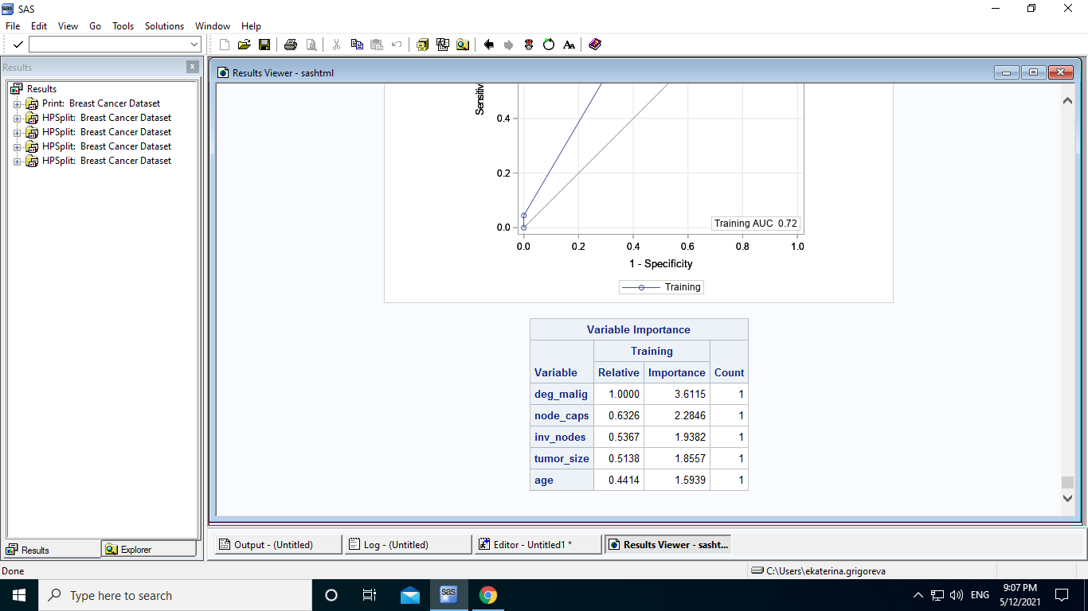

c. Navigate the contents of Results View by clicking on HPSplit breast-cancer-dataset, and then by selecting Model Assessment. Examine the confusion matrix, fit statistics, and variable importance.

The above screenshot of the Model Information tells us that there are 286 observations in total. The number of leaves after pruning is 6 compared to 51 before pruning. The tree depth is 5 which means that there are 5 features that the classification has been made upon.

The above screenshot of the Model-Based Confusion Matrix tells that the number of correct predictions is 189+38=227, and the number of incorrect predictions is 47+12=59.

The error rate, which evaluates the accuracy of the tree, is 5.97% for no-recurrence events, and 55.29% for recurrence events.

The Model-Based Fit Statistics for Selected Tree table shows the following main characteristics of the model:

Number of leaves = 6

ASE = 0.1599 = 15.99%
ASE, also known as the Brier score, is an average square error. It specifies the metric for reduced-error pruning.

Misclass = 0.2063 = 20.63%
Misclass measure shows the misclassification rate of the data sample of 286 observations.

Sensitivity = 0.9403 = 94.03%
Sensitivity is calculated as the number of correct positive predictions divided by the total number of positives. It is also called Recall (REC) or true positive rate (TPR). The best sensitivity is 1.0, whereas the worst is 0.0.

Specificity = 0.4471 = 44.71%
Specificity is calculated as the number of correct negative predictions divided by the total number of negatives. It is also called true negative rate (TNR). The best specificity is 1.0, whereas the worst is 0.0.

Entropy = 0.7106 = 71.06%
The GROW statement specifies the entropy criterion for splitting the observations during the process of recursive partitioning that results in a large initial tree. The PRUNE statement requests cost-complexity pruning to select a smaller subtree that avoids overfitting the data.

Gini = 0.3198 = 31.98%
Gini impurity measure is calculated by subtracting the sum of squared probabilities of each class from one. A feature with a lower Gini index is chosen for a split.

RSS = 91.4723
RSS (residual sum of squares) - In order to find out the “best” split, we must minimize the RSS.

AUC = 0.7204 = 72.04%
The Area Under the Curve (AUC) is the measure of the ability of a classifier to distinguish between classes. The higher the AUC, the better the performance of the model at distinguishing between the positive and negative classes.

The above screenshot of the Variable Importance shows the importance of the features in order that the algorithm is taking into consideration when splitting the dataset. The most important variable is deg_malig, then node_caps, then inv_nodes, then tumor_size, and finally age. Age is a less important feature that is considered when splitting the data.

2. Using the confusion matrix, compute the following assessment metrics accuracy, recall, and precision (see lecture for formulas).
Condition for marks: 3 points for accuracy, 1 point for precision, and 1 point for recall.

The following screenshot of a Model-Based Confusion Matrix provides the following information:

Model-Based Confusion Matrix
Actual | Predicted |  | Error Rate
Actual | no-recurrence events  Class = 1 | recurrence events  Class = 0 | Error Rate
no-recurrence events  Class = 1 | 189  TP | 12  FN | 0.0597
recurrence events  Class = 0 | 47  FP | 38  TN | 0.5529

Accuracy - represents the number of correctly classified data instances over the total number of data instances.

Accuracy = number of correct predictions / total number of predictions

Accuracy = (189 + 38) / 286 = 227 / 286 = 0.7937 = 79.37%

Precision - in an imbalanced classification problem with two classes, precision is calculated as the number of true positives divided by the total number of true positives and false positives. The result is a value between 0.0 for no precision and 1.0 for full or perfect precision.

Precision = TruePositives / (TruePositives + FalsePositives)
Precision = 189 / (189+47) = 189 / 236 = 0.8008 = 80.08%
Recall - In an imbalanced classification problem with two classes, recall is calculated as the number of true positives divided by the total number of true positives and false negatives. The result is a value between 0.0 for no recall and 1.0 for full or perfect recall.

Recall = TruePositives / (TruePositives + FalseNegatives)
Recall = 189 / (189 + 12) = 0.9402 = 94.02%
3. Change the grow algorithm to “gini” and recompute the metrics from question 2. Does entropy build a more accurate classifier or gini?

ods graphics on;

proc hpsplit data=breast_cancer;
class class age menopause tumor_size inv_nodes node_caps deg_malig breast breast_quad irradiat;
model class=class age menopause tumor_size inv_nodes node_caps deg_malig breast breast_quad irradiat;
grow Gini;
prune costcomplexity;
run;

The screenshot of the above code:
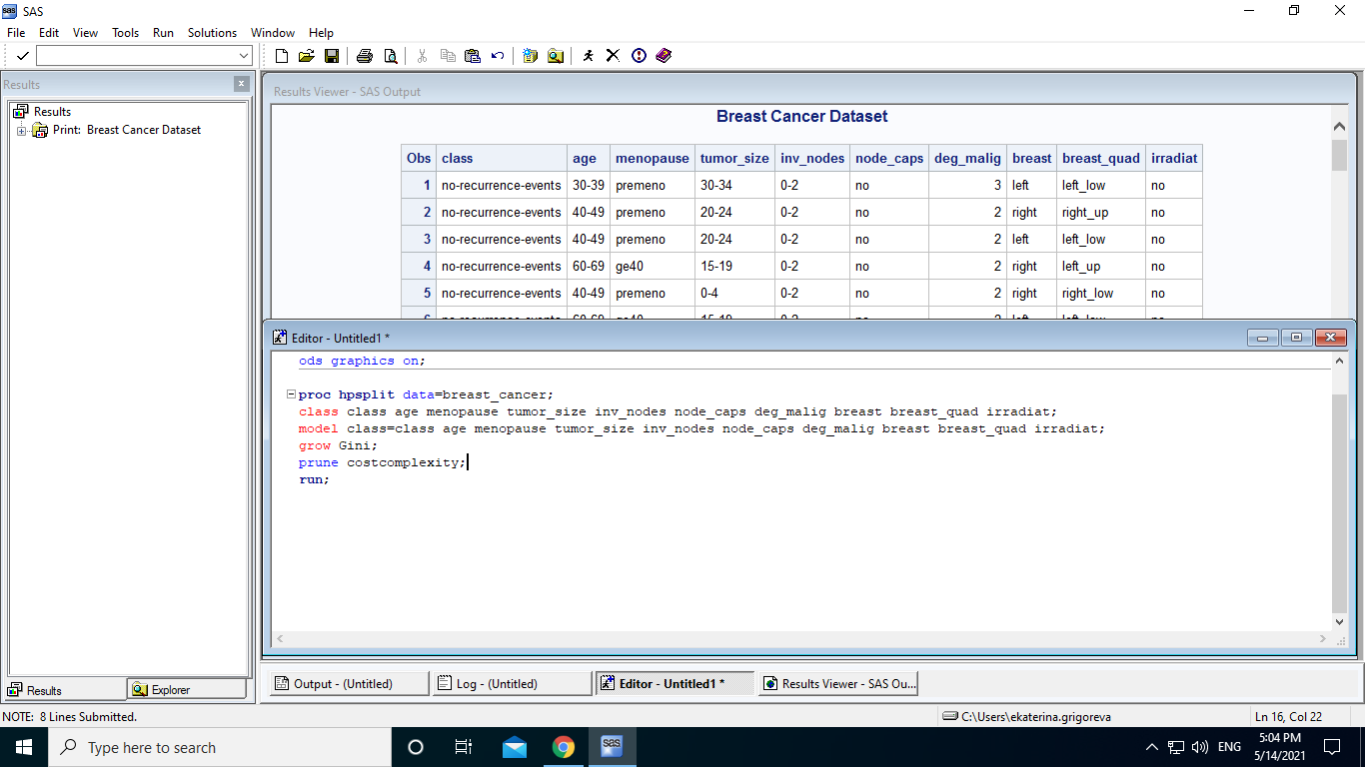

The result of the above code is shown by the following screenshots:

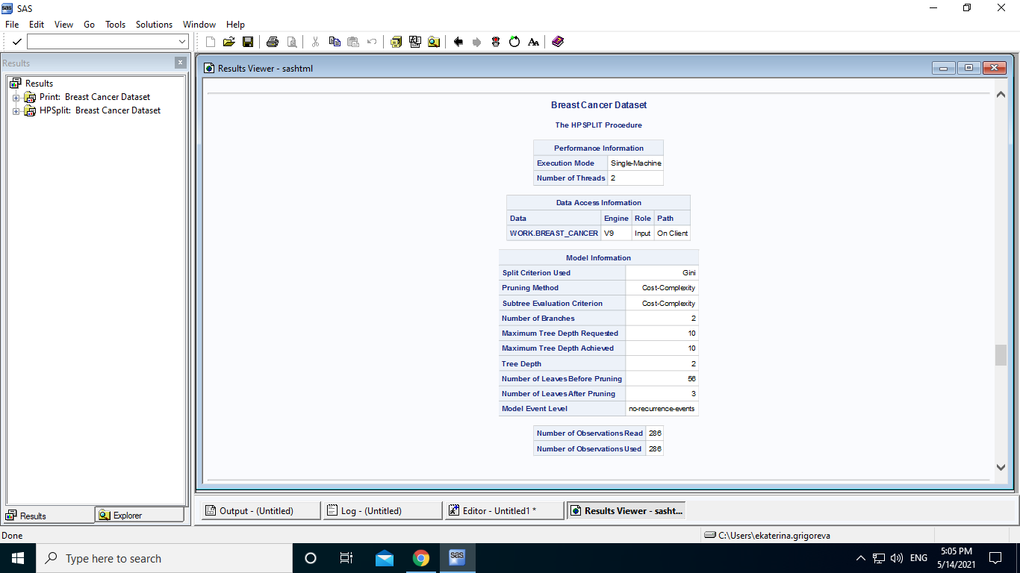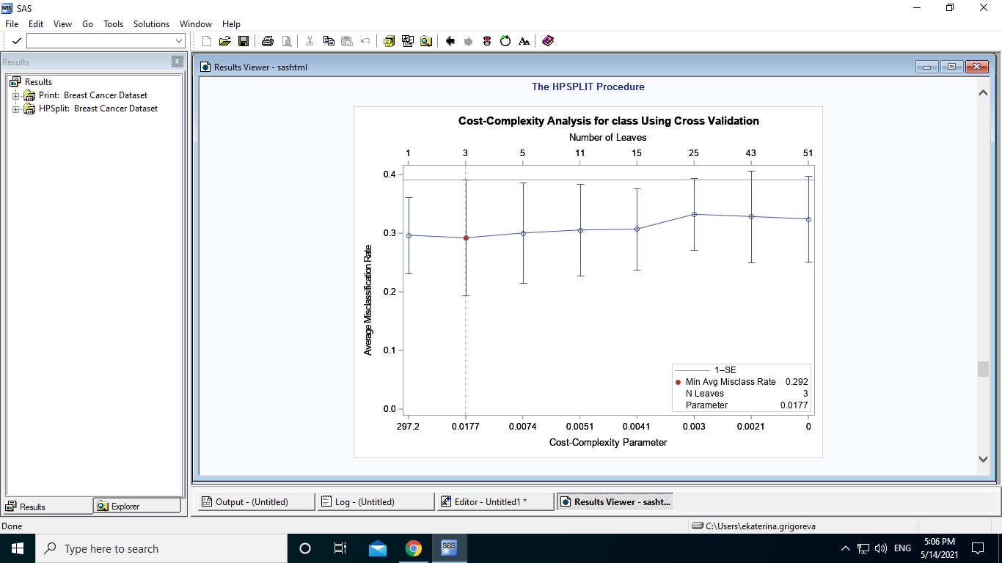

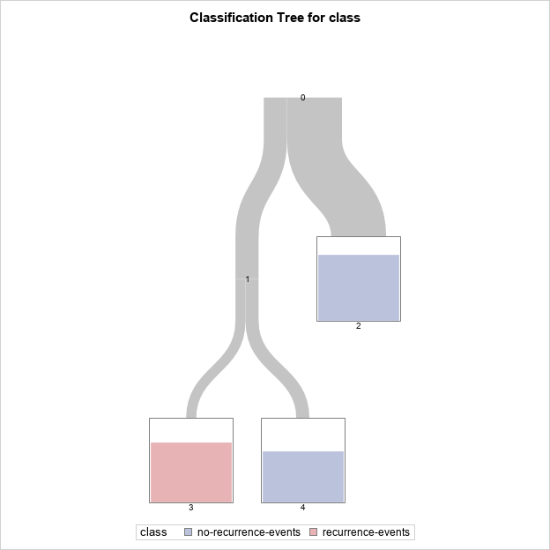

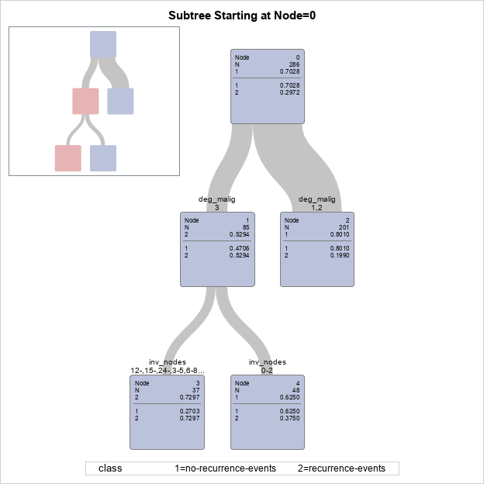

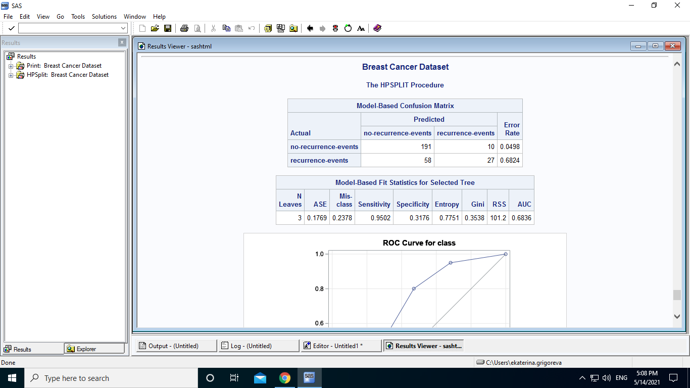

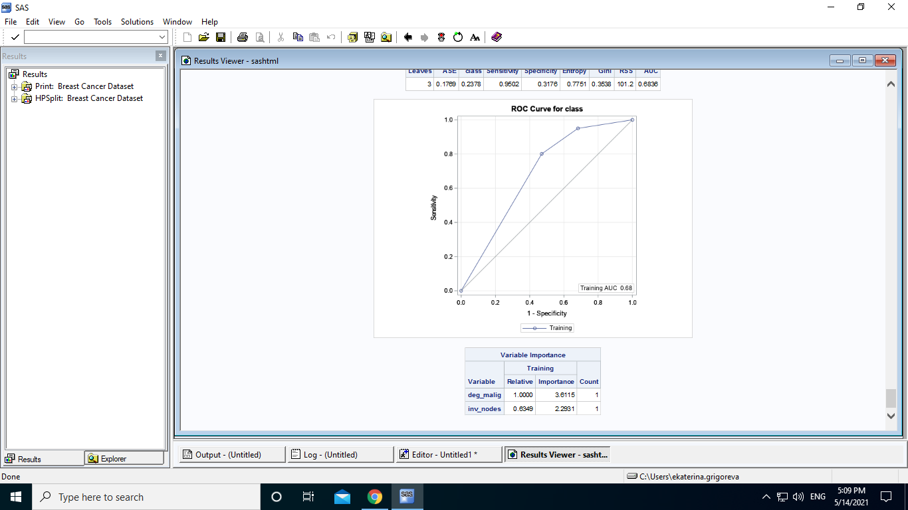

Based on the Model-Based Confusion Matrix,

Model-Based Confusion Matrix
Actual | Predicted |  | Error Rate
Actual | no-recurrence events  Class = 1 | recurrence events  Class = 0 | Error Rate
no-recurrence events  Class = 1 | 191  TP | 10  FN | 0.0498
recurrence events  Class = 0 | 58  FP | 27  TN | 0.6824

Accuracy - represents the number of correctly classified data instances over the total number of data instances.

Accuracy = number of correct predictions / total number of predictions

Accuracy = (191 + 27) / 286 = 218 / 286 = 0.7622 = 76.22%

Precision - in an imbalanced classification problem with two classes, precision is calculated as the number of true positives divided by the total number of true positives and false positives. The result is a value between 0.0 for no precision and 1.0 for full or perfect precision.

Precision = TruePositives / (TruePositives + FalsePositives)
Precision = 191 / (191 + 58) = 0.7670 = 76.70%
Recall - In an imbalanced classification problem with two classes, recall is calculated as the number of true positives divided by the total number of true positives and false negatives. The result is a value between 0.0 for no recall and 1.0 for full or perfect recall.

Recall = TruePositives / (TruePositives + FalseNegatives)
Recall = 191 / (191 + 10) = 0.9502 = 95.02%

Comparison table
 | Classifier | Gini
Accuracy | 0.7937 = 79.37% | 0.7622 = 76.22%
Precision | 0.8008 = 80.08% | 0.7670 = 76.70%
Recall | 0.9402 = 94.02% | 0.9502 = 95.02%

Ideally we should choose one main metric to focus on because it is very hard to work on machine learning if you have many metrics to optimize.
If we take Accuracy metric, which is the proportion of correct predictions, the entropy build classifier is a more accurate classifier, because it has a higher Accuracy.

